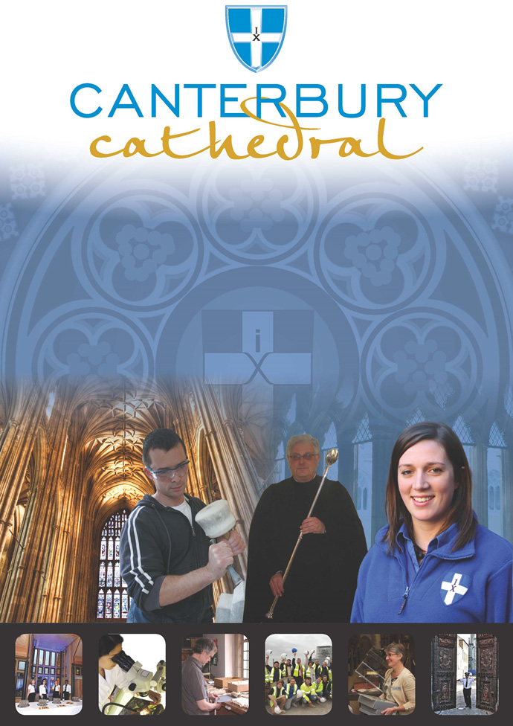

PROFILE OF CANTERBURY CATHEDRAL
St Augustine, the first Archbishop of Canterbury, arrived on the coast of Kent as a missionary to England in 597 AD. He came from Rome, sent by Pope Gregory the Great. It is said that Gregory had been struck by the beauty of Angle slaves he saw for sale in the city market and dispatched Augustine and some monks to convert them to Christianity. Augustine was given a church at Canterbury (St Martin’s, after St Martin of Tours, still standing today) by the local King, Ethelbert whose Queen, Bertha, a French Princess, was already a Christian. This building had been a place of worship during the Roman occupation of Britain and is the oldest church in England still in use. Augustine had been consecrated a bishop in France and was later made an archbishop by the Pope. He established his seat within the Roman city walls (the word cathedral is derived from the Latin word for a chair ‘cathedra’, which is itself taken from the Greek ‘kathedra’ meaning seat.) and built the first cathedral there, becoming the first Archbishop of Canterbury. Since that time, there has been a community around the Cathedral offering daily prayer to God; this community is arguably the oldest organisation in the English speaking world. The present Archbishop, The Most Revd Justin Welby, is 105th in the line of succession from Augustine.
Augustine’s original building lies beneath the floor of the nave– it was extensively rebuilt and enlarged by the Saxons, and the Cathedral was rebuilt completely by the Normans in 1070 following a major fire. There have been many additions to the building over the last nine hundred years, but parts of the quire and some of the windows and their stained glass date from the 12th century.
By 1077, Archbishop Lanfranc had rebuilt it as a Norman church, described as “nearly perfect”. A staircase and parts of the North Wall – in the area of the North West transept also called the Martyrdom – remain from that building.
During the Second World War, the Precincts were heavily damaged by enemy action and the Cathedral’s Library was destroyed. Thankfully, the Cathedral itself was not seriously harmed, due to the bravery of the team of fire watchers, who patrolled the roofs and dealt with the incendiary bombs dropped by enemy bombers.
Today, the Cathedral stands as a place where prayer to God has been offered daily for over 1,400 years; nearly 2,000 services are held each year, as well as countless private prayers from individuals. The Cathedral offers a warm welcome to all visitors – its aim is to show people Jesus, which we do through the splendour of the building as well as the beauty of the worship.

THE WORK OF THE CATHEDRAL
The work of the Cathedral is carried out by over 300 paid staff, supported by some 500 volunteers. The ‘corporate body’ responsible for the management of the Cathedral is the Chapter of Canterbury who are advised by the Cathedral Council and the College of Canons.

The Chapter of Canterbury (Chapter)
The Chapter are responsible for all aspects of the day-to-day management of the Cathedral. Chapter comprises the Dean, the Residentiary Canons, the Receiver General and four additional persons appointed by the Archbishop.

The Cathedral Council
The Council represents the Cathedral community as well as the wider local and regional community. It has 20 members, drawn from a wide variety of organisations. Its duty is to further and support the work of the Cathedral Church in spiritual, pastoral, evangelistic, social and ecumenical areas.

The College of Canons
The College of Canons is composed of 30 Honorary, Lay and Provincial Canons, appointed by the Archbishop and it supports the life of the Cathedral in many different ways.

The Cathedral Trust
The Cathedral Trust is a separate charity that is solely for the benefit of the Cathedral. Since 1974, it has assisted with the restoration, maintenance and improvement of the fabric and contents of Canterbury Cathedral and the provision, promotion and encouragement of music
The Cathedral is well-known all over the world and we welcome more than 1 million visitors and worshippers every year. The Cathedral is more than just a beautiful old building and heritage site; it is a working, living church which maintains a tradition of welcome and worship that has been practiced here for over 1400 years.

Friends
The Friends of Canterbury Cathedral was founded in 1927 by the distinguished scholar and poet Dean George Allen Kennedy Bell. The Organisation was the first of its kind in the world.
The Friends are the Cathedral’s fan club. Admirers of the building, its history and its community, Friends are a part of the Cathedral and work together to preserve it forever, contributing financially - and directly – to many individual and vital projects.

The Cathedral Shop
The Canterbury Cathedral Shop is a large gift shop in the heart of the city of Canterbury. It has an impressive range of high quality gifts, mostly British, and their own exclusive award winning designs.
The Shops wide range of merchandise includes replica historical artefacts, books and CD’s of the world-famous Canterbury Cathedral choir.

CANTERBURY CATHEDRAL LODGE
General Manager
Image Database Archivist / Cataloguer
Inventory Administrator
Housekeeping Supervisor

Room Attendants

Banqueting / Bar staff

Kitchen Porters

Receptionists

Chef de Partie

Sous Chef

Catering Manager
Conference & Events Coordinators
Night Porters

Breakfast Supervisor

Conference & Banqueting Supervisors

Sales and Marketing Manager
Head Chef
Head Housekeeper

Senior Receptionist

Accommodation Manager

JOB PROFILE
To ensure and supervise the smooth operation of the Conference & Banqueting (C&B) function within the Lodge and any other location in the Cathedral Precincts where events are being hosted, incorporating Front and Back of House areas. To work closely with the Catering Manager and liaise with the Sales Office team to provide excellent customer service at all times.

The Conference & Banqueting Supervisor reports directly to the Catering Manager and liaises with the Sales Office team to provide excellent customer service at all times.

PRINCIPAL TASKS
- To meet & greet all conference and event customers, ensuring needs are met and expectations exceeded.
- To check and supervise the Conference & Banqueting team.
- To manage a wide range of conferences and events, including high volume banqueting and wedding receptions, VIP private dining and festive events.
- To follow all Standard Operating Procedure (SOP’S), ensure staff are aware and trained in these standards.
- In the absence of the Catering Manager, attend all relevant meetings as required.
- To adhere to the procedures in your department, reporting any discrepancies to the Catering Manager.
- To have a full understanding of all room types, location, configurations and to have sound knowledge of all hotel facilities, local area and directions to the hotel.
- To ensure all documentation and information on your shift, relating to the operation is presented promptly, clearly and accurately and kept in the correct file for future reference.
- To check, monitor and follow up all accounting requirements involving individual, function and group postings and payments in accordance with the hotel’s accounting procedure.
- To ensure all meeting rooms are set to the required standard on a daily basis.
- To carry out/issue cleaning rotas as required in order for all areas to be as above point. Carry out spot checks and regular checks.
- In the absence of the Catering Manager, complete rotas & timesheets paying particular attention to staff ratio’s so that the department meets forecasted business demands.
- To provide supervisory cover for breakfast and other catering activities in the absence of the Catering Manager or Breakfast Supervisor as required.
- To order stock and equipment and maintain requisition system to ensure accurate stock & cost control.
- To ensure the C&B Health & Safety folder is maintained and all paperwork is kept up to date.
- To take reasonable care for the health and safety of yourself and other people who may be affected by what you do or do not do at work.
- To co-operate with the management of the Chapter of Canterbury to enable it to comply with any prohibitions and requirements imposed on it by the relevant health and safety legislation.
- To refrain from interfering with or misusing anything provided by the Chapter of Canterbury in the interests of health, safety and welfare.
- To inform your Manager of any shortcomings in Chapter’s arrangements for carrying out the Health and Safety Policy.
- To use all equipment in accordance with your training and instructions and report to your Manager any defects in plant, equipment or premises that could present a risk to health and safety.
- To inform employees of the possible hazards in their areas, the protective control measures that have been put in place, how and when to use them and the safe operational procedures that must be adopted.
- To ensure that all health and safety rules are observed and that appropriate measures are taken for persistent violations.
- In conjunction with the Health and Safety Officer, conduct regular inspections of your staff working areas and the equipment being used, to ensure its continued safe operation.
- Carry out any reasonable task that may be required by management.

PERSON SPECIFICATION
The personal specification below indicates the qualifications, experience, knowledge and skills required to undertake the role effectively.

ESSENTIAL KNOWLEDGE AND SKILLS
- Experience in a similar role in a high volume conference and events environment specifically with experience of hosting weddings receptions.

- Demonstrable interpersonal and customer service skills. Pro-active who can work to strict deadlines.

- Able to give guidance and instruction to banqueting staff.

- Able to prioritise, organise and be self-disciplined with exceptional host and people skills.

- Basic keyboard and clerical skills.

- Understanding of and sympathy with the aims and purposes of the Cathedral, its mission and ministry.

DESIRABLE KNOWLEDGE AND SKILLS

- Up to date with food safety, fire and health and safety legislation

- Food Hygiene Certificate

- Basic 1st Aid Certificate

- Basic Health and Safety Certificate

PERSONAL ATTRIBUTES
- Sufficiently active and fit enough to lift and move equipment, furniture and luggage in order to fulfil the requirements of the position.

- Well presented.

- Flexible and adaptable to accommodate a diverse range of clients.

- Flexible in approach to working times as this position includes working irregular days to match the business demands of the CCL which includes weekends.

TERMS AND CONDITIONS

Grade
6

Salary
£20,805 per annum.

Working hours
A minimum of 40 hours per week (excluding breaks), normally five days out of seven including evenings, weekends and public holidays. The position holder should be flexible in their approach to hours worked as these will depend on operational needs.

Annual holiday

Based upon the hours stated above, the annual entitlement is 25 days plus 8 public holidays and 2 Chapter Days.

Probation Period
All new posts are subject to a probation period. New staff will meet regularly with their line manager to assess both formally and informally progress on work and performance.

Training
Training needs are assessed continuously and appropriate on the job training is provided.

Pension scheme
The Chapter of Canterbury offer a Stakeholder pension to all employees. Your age and salary will determine if you are to be automatically enrolled into the pension scheme
The Chapter of Canterbury contribute 7½ % of salary into a Stakeholder Pension Scheme. Staff in the pension scheme are insured against death in service 3 x annual salary to the age of 70.

Parking
Chapter is not able to offer staff parking on site.

Staff benefits
We are able to offer a range of staff benefits including discounts in local shops, restaurants and sports centres.

Additional Requirements
To ensure that you have no medical condition that can be caused by or made worse by the work you do, upon appointment the post holder will be required to complete a medical questionnaire to confirm that the applicant is sufficiently fit enough to fulfil the requirements of the position which will include, lifting and movement of equipment furniture and luggage and if thought necessary will be required to attend a medical by our Occupational Health Service Provider. This may be repeated on an annual / ad hoc basis.

EQUALITY STATEMENT
The Chapter of Canterbury recognises that discrimination and victimisation is unacceptable and that it is in the interests of the organisation and its employees to utilise the skills of the total workforce. It is the aim of the organisation is to ensure that no employee or job applicant receives less favourable facilities or treatment (either directly or indirectly) in recruitment or employment on grounds of age, disability, gender / gender reassignment, marriage / civil partnership, pregnancy / maternity, race, religion or belief, sex, or sexual orientation.
June 2019
This job description is provided to assist the post holder to know their principal duties. It may be amended from time to time in consultation with you, by, or on behalf of, the Head of the Department, without change to the level of responsibility appropriate to the grading of the post.

HOW TO APPLY

A CV should be submitted online via our web page.

Application details can be found at:

http://canterbury-cathedral.org/community/employment

The closing date for this post is:

Sunday 30th June 2019

